ASSIGNMENT – ADVANCED K8s

Now that you Storage class of NFS on your kubeADM – that is great but this is not the most optimized storage to choose for production

Now you need to choose GLUSTERFS OR OPENEBS

If you choose OPENEBS do below if not skip to GLUSTERFS

Let me introduce to you OPENEBS

Please backup you cluster before doing anything here

<https://openebs.io/docs/concepts/cstor>

read the article

understand this chart :

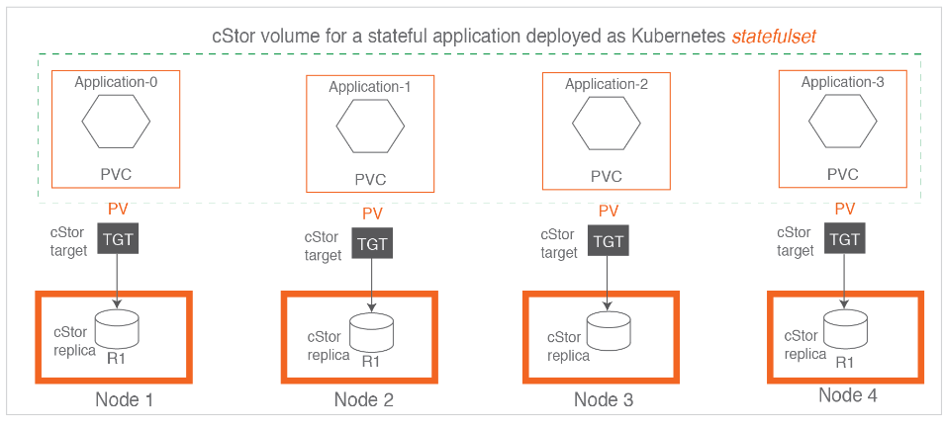

Now make it happen on kubeadm:

**** make sure to do openebs cstore

*** make to choose method 2 in the guide (not HELM )

<https://computingforgeeks.com/deploy-and-use-openebs-container-storage-on-kubernetes/>

# GLUSTERFS:

Welcome to glusterfs challenge

Please backup you cluster before doing anything here

Watch the video

<https://drive.google.com/file/d/0B667S2caJiy7QVpzVVFNQVdyaVE/view?usp=sharing>

First read this guide:

<https://github.com/gluster/gluster-kubernetes>

LAST PART:

Setup istio on the same cluster:

Read this:

<https://makeoptim.com/en/service-mesh/kubeadm-kubernetes-istio-setup/>

also read this:

<https://www.lisenet.com/2021/install-metallb-and-istio-ingress-gateway-with-mtls-for-kubernetes/>

for minikube:

<https://medium.com/@emirmujic/istio-and-metallb-on-minikube-242281b1134b>

With kiali and istio gateway (if you installed nginx ingress – please delete it before)

Setup kiali : <https://istio.io/latest/docs/ops/integrations/kiali/>

Show me screenshots of your kiali and gateway route of sample app